Waves Worksheet
Amplitude – Height of wave. Measured from the equilibrium position to the top of a crest or the bottom of a trough (see vertical arrow).
Wavelength – length of a single wave cycle (horizontal arrow). Measure distance between 2 identical points on consecutive waves.

Frequency – number of waves that pass a point per second Units = Hz = waves/second

Speed = wavelength x frequency
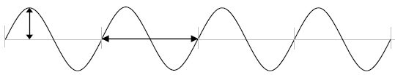

The time from the beginning to the end of the wave in each situation is 1 second.
Wave 1 1 second
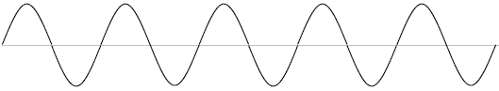
- How many wave cycles are completed in this diagram? _____
- Wavelength ________ cm d) Amplitude _______ cm
- Frequency ________ Hz e) Speed _______ cm/s

Wave 2
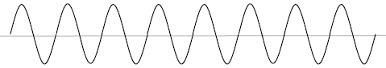
- How many wave cycles are completed in this diagram? _____
- Wavelength ________ cm d) Amplitude _______ cm
- Frequency ________ Hz e) Speed _______ cm/s

Wave 3
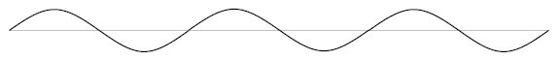
- How many wave cycles are completed in this diagram? _____
- Wavelength ________ cm d) Amplitude _______ cm
- Frequency ________ Hz e) Speed _______ cm/s

Wave 4
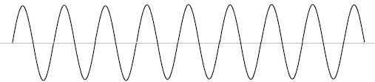
- How many wave cycles are completed in this diagram? _____
- Wavelength ________ cm d) Amplitude _______ cm
- Frequency ________ Hz e) Speed _______ cm/s

Wave 5

- How many wave cycles are completed in this diagram? _____
- Wavelength ________ cm d) Amplitude _______ cm
- Frequency ________ Hz e) Speed _______ cm/s

Wave 6
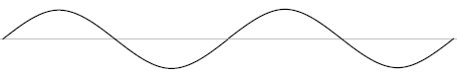
- How many wave cycles are completed in this diagram? _____
- Wavelength ________ cm d) Amplitude _______ cm
- Frequency ________ Hz e) Speed _______ cm/s

Wave 7

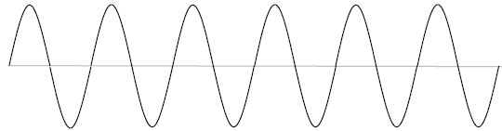
- If this entire wave is 30 meters long, what is the wavelength of this wave? _______.
- Explain how you worked out your answer to part a)

